Name: B.Pooja
Hall Ticket: 2303A52141
Batch: 41
Task 1: Auto-Genera ng Func on Documenta on in a Shared Codebase
Python script containing mul ple func ons without any docstrings.
Prompt:
Write a Python program for a calculator that performs basic arithmetic operations such as addition, subtraction, multiplication, and division based on user input. The program should keep running until the user decides to exit. Use separate functions for each operation and a main function to control the flow. Handle invalid inputs and division by zero properly. Do not include any comments or docstrings.
Code:
def add(x, y): return x + y
def subtract(x, y): return x - y
def multiply(x, y): return x * y
def divide(x, y): if y == 0: return "Error: Division by zero is not allowed." return x / y def get_user_input(): while True: try:
num1 = float(input("Enter the first number: ")) num2 = float(input("Enter the second number: ")) return num1, num2 except ValueError:
print("Invalid input. Please enter numeric values.") def main():
while True:
print("\nSelect operation:") print("1. Add") print("2. Subtract") print("3. Multiply") print("4. Divide") print("5. Exit")
choice = input("Enter choice (1/2/3/4/5): ")
if choice == '5':
print("Exiting the calculator. Goodbye!") break
if choice in ['1', '2', '3', '4']: num1, num2 = get_user_input()
if choice == '1':
print(f"{num1} + {num2} = {add(num1, num2)}") elif choice == '2':
print(f"{num1} - {num2} = {subtract(num1, num2)}") elif choice == '3':
print(f"{num1} * {num2} = {multiply(num1, num2)}") elif choice == '4':
result = divide(num1, num2) print(f"{num1} / {num2} = {result}") else:
print("Invalid choice. Please select a valid operation.") if __name__ == "__main__":
main()

Google Doc String:Prompt:
Insert Google-style docstrings for every function in the provided Python calculator program. Each docstring must be limited to 2–3 lines and should clearly explain the function’s purpose, mention all parameters with their data types, state the return value with its data type, and include at least one example of usage. The program’s logic, structure, and output must remain unchanged; only add the docstrings above the function definitions.
Code:
def add(x, y):
"""Add two numbers.

Args:
x (float): The first number. y (float): The second number.

Returns:
float: The sum of x and y.

Example:
>>> add(2, 3)
5 """ return x + y def subtract(x, y):
"""Subtract two numbers.

Args:
x (float): The first number. y (float): The second number.

Returns:
float: The difference of x and y.

Example:
>>> subtract(5, 3)
2 """ return x - y def multiply(x, y):

"""Multiply two numbers.

Args:
x (float): The first number. y (float): The second number.

Returns:
float: The product of x and y.

Example:
>>> multiply(2, 3)
6 """ return x * y def divide(x, y):
"""Divide two numbers.

Args:
x (float): The numerator. y (float): The denominator.

Returns:
float or str: The quotient of x and y, or an error message if division by zero.
Example:
>>> divide(6, 3)
2.0 """ if y == 0: return "Error: Division by zero is not allowed." return x / y def get_user_input():
"""Get two numeric inputs from the user.

Returns:
tuple: A tuple containing two floats entered by the user.
Example:
>>> get_user_input()
(2.0, 3.0)
""" while True: try:
num1 = float(input("Enter the first number: ")) num2 = float(input("Enter the second number: ")) return num1, num2 except ValueError:
print("Invalid input. Please enter numeric values.") def main():
"""Run the interactive calculator.

Continuously prompts the user to select an arithmetic operation and input numbers until they choose to exit.

Example:
>>> main()
(Interactive session)
""" while True:
print("\nSelect operation:") print("1. Add") print("2. Subtract") print("3. Multiply") print("4. Divide") print("5. Exit")
choice = input("Enter choice (1/2/3/4/5): ")
if choice == '5':
print("Exiting the calculator. Goodbye!") break
if choice in ['1', '2', '3', '4']: num1, num2 = get_user_input()
if choice == '1':
print(f"{num1} + {num2} = {add(num1, num2)}") elif choice == '2':
print(f"{num1} - {num2} = {subtract(num1, num2)}") elif choice == '3':
print(f"{num1} * {num2} = {multiply(num1, num2)}") elif choice == '4':
result = divide(num1, num2) print(f"{num1} / {num2} = {result}") else:
print("Invalid choice. Please select a valid operation.") if __name__ == "__main__":
main()

Output:
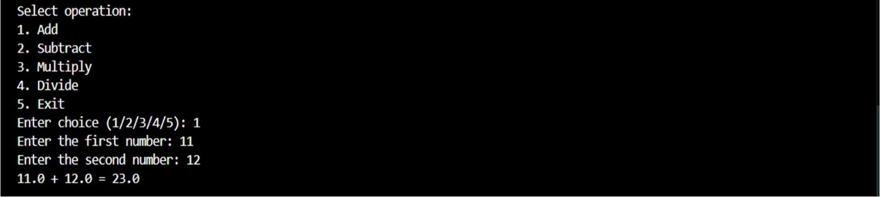
Explana on:
This code implements a simple menu-driven calculator that performs addi on, subtrac on, mul plica on, and division based on user input. It uses func ons for each opera on and includes input valida on to handle invalid values and division by zero.

Task 2: Enhancing Readability Through AI-Generated Inline Comments
Python Code for Bubble Sort:
Prompt:
Create a Python program that implements the Bubble Sort algorithm. The program should accept a list of numbers from the user and sort them in ascending order.Code:
def bubble_sort(arr):
n = len(arr) for i in range(n):
for j in range(0, n-i-1): if arr[j] > arr[j+1]:
arr[j], arr[j+1] = arr[j+1], arr[j] return arr
numbers = input("Enter the list of numbers to sort: ") numbers = numbers.split() numbers = [int(num) for num in numbers] sorted_numbers = bubble_sort(numbers) print("Sorted numbers are:", sorted_numbers)

Updated prompt:
Based on the program above, automatically add inline comments only where the logic is complex or not immediately clear. Also include appropriate docstrings for both the function and the overall program.Code:
def bubble_sort(arr):
"""
Bubble sort algorithm to sort the list of numbers.
""" n = len(arr) for i in range(n): for j in range(0, n-i-1): if arr[j] > arr[j+1]:
arr[j], arr[j+1] = arr[j+1], arr[j] return arr
numbers = input("Enter the list of numbers to sort: ") numbers = numbers.split()
numbers = [int(num) for num in numbers] sorted_numbers = bubble_sort(numbers) print("Sorted numbers are:", sorted_numbers)

Output:
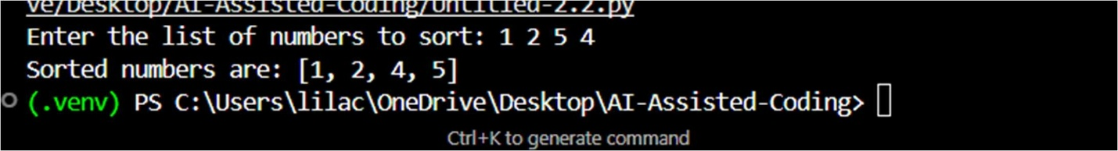
AI support is applied to insert inline comments only in sections where the logic is complicated or unclear, while avoiding obvious parts of the code. This improves readability without filling the program with unnecessary comments.
Task 3:
Prompt:
Create a professional module-level docstring for this Python file. The docstring should clearly state the module’s purpose, list any required dependencies, describe the main classes and functions, and provide a brief usage example.
Code:
class Student: def __init__(self, name, marks):
self.name = name self.marks = marks

def add_student(student_list, name, marks): student_list.append(Student(name, marks))

def calculate_average(student_list):
if not student_list:
return 0 total = sum(student.marks for student in student_list) return total / len(student_list)

def display_students(student_list): for student in student_list:
print(f"Name: {student.name}, Marks: {student.marks}")
#Generate a professional module-level docstring for this Python file.The docstring should explain the purpose of the module, required dependencies, describe the key classes and functions, and include a short example of how the module can be used.
"""This module provides a simple implementation of a student management system. It allows you to create student objects, add them to a list, calculate the average marks of the students, and display their information. Dependencies:
- Python 3.x
Key Classes and Functions:
- Student: A class representing a student with a name and marks.
- add_student(student_list, name, marks): A function to add a student to the student list. - calculate_average(student_list): A function to calculate the average marks of the students in the list.
- display_students(student_list): A function to display the name and marks of each student in the list.
Example Usage:
```python
# Create an empty list to hold students students = []
# Add some students to the list add_student(students, "Alice", 85)
add_student(students, "Bob", 90) add_student(students, "Charlie", 78)
# Display the studentsdisplay_students(students)
# Calculate and print the average marksaverage = calculate_average(students) print(f"Average Marks: {average}")
```"""

Output:
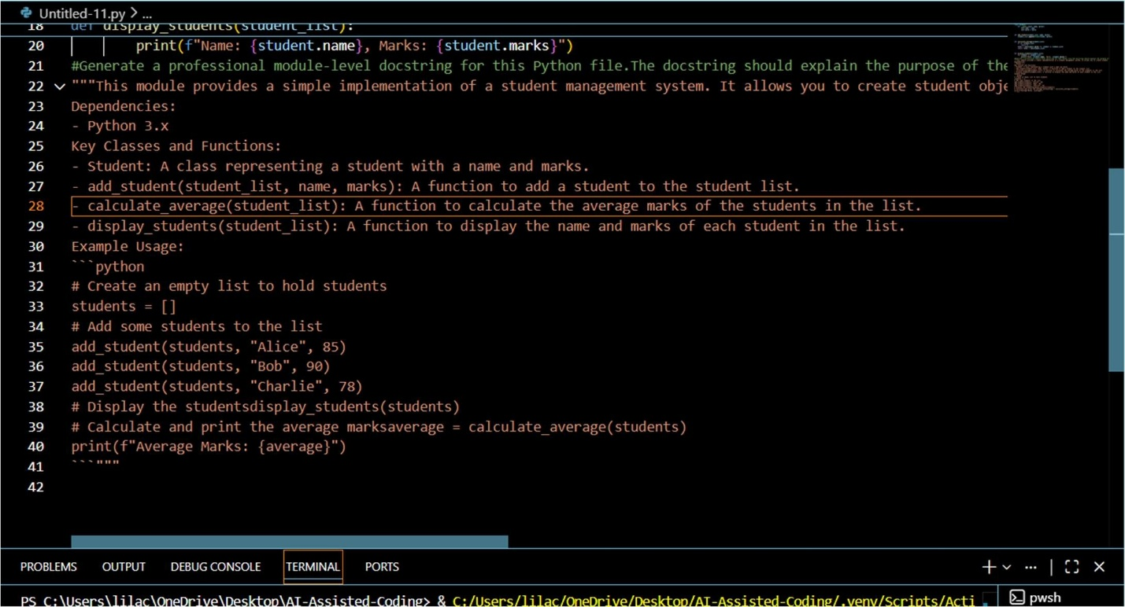
Explain on:
This task shows how to create a basic Python module and leverage an AI tool to produce clear and professional documentation.
Task 4: Conver ng Developer Comments into Structured Docstrings
Prompt:
Replace the inline comments within each function with appropriate Google-style docstrings. Keep the original intent intact, eliminate unnecessary inline comments, and do not alter the function logic.
Code:
def calculate_average(marks):
# This function calculates the average of student marks
# First, it checks whether the marks list is empty
# If the list is empty, it returns 0 to avoid division errors
# Then it adds all the marks in the list
# Finally, it divides the total by the number of marks total = 0 for m in marks: total += m
if len(marks) == 0:
return 0

return total / len(marks)

def find_top_student(students):
# This function finds the student with the highest marks
# It assumes students is a list of dictionaries
# Each dictionary contains the student's name and marks # It compares marks of each student and tracks the highest one top_student = None highest = 0
for student in students: if student["marks"] > highest: highest = student["marks"] top_student = student["name"]
return top_student
#Convert the inline comments inside each function into proper Google-style docstrings. Preserve the original meaning, remove redundant inline comments, and keep the function logic unchanged. def calculate_average(marks):
"""
Calculate the average of student marks.

This function takes a list of marks and returns the average. If the list is empty, it returns 0 to avoid division errors.

Args:
marks (list): A list of numerical marks.
Returns:
float: The average of the marks, or 0 if the list is empty.
""" total = 0 for m in marks: total += m
if len(marks) == 0:
return 0
return total / len(marks) def find_top_student(students):
"""Find the student with the highest marks.
This function takes a list of student dictionaries, where each dictionary contains the student's name and marks. It compares the marks of each student and returns the name of the student with the highest marks.
Args:
students (list): A list of dictionaries, each containing 'name' and 'marks' keys.
Returns:
str: The name of the student with the highest marks.
""" top_student = None highest = 0

for student in students: if student["marks"] > highest: highest = student["marks"] top_student = student["name"]
return top_student

Output:
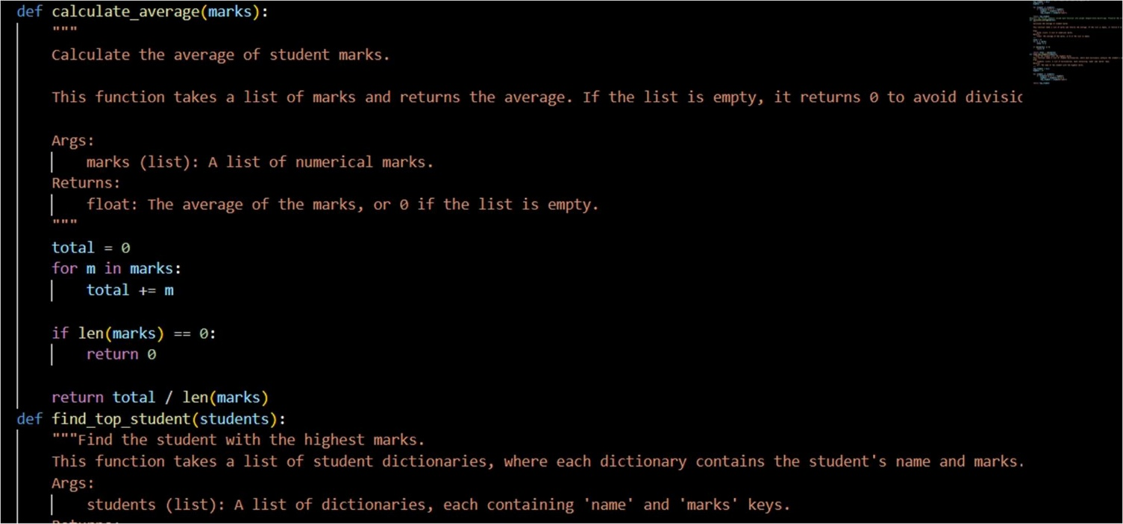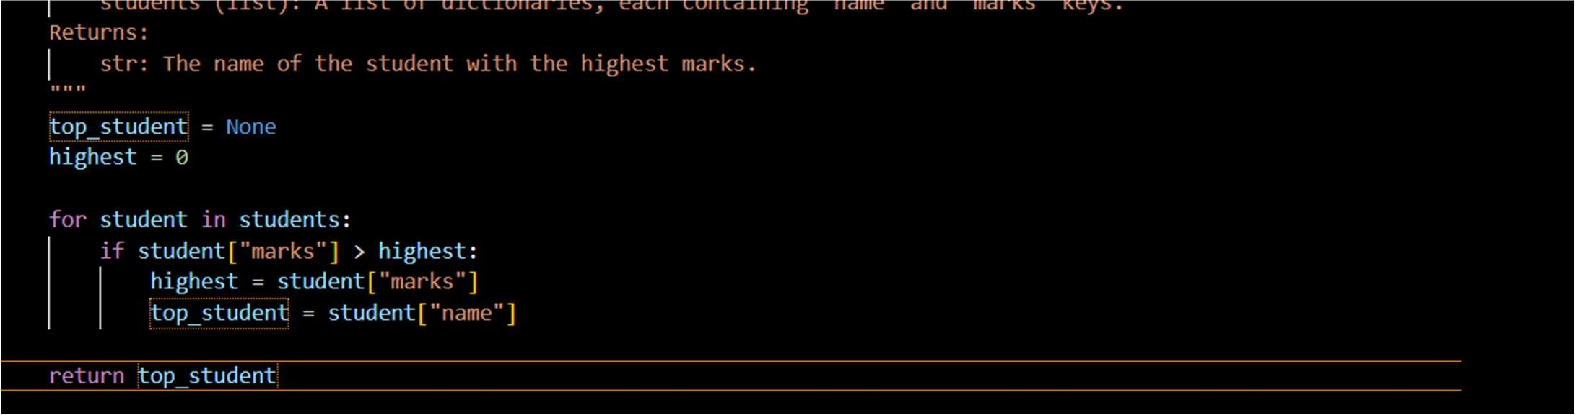
Explana on:
The program analyzes student records by computing average scores and determining the highest-performing student. Inline comments are converted into structured docstrings to enhance readability and maintain consistent documentation.
Task 5: Building a Mini Automa c Documenta on Generator
Prompt:
Review the calculator.py file and add placeholder Google-style docstrings to every class and function that currently lacks one. Do not modify any existing logic or functionality—only include clean, well-structured docstrings.
Code:
class Calculator: def add(self, a, b):
return a + b

def subtract(self, a, b):
return a - b

def multiply(a, b): return a * b

def divide(a, b): if b == 0: return None return a / b

Output:
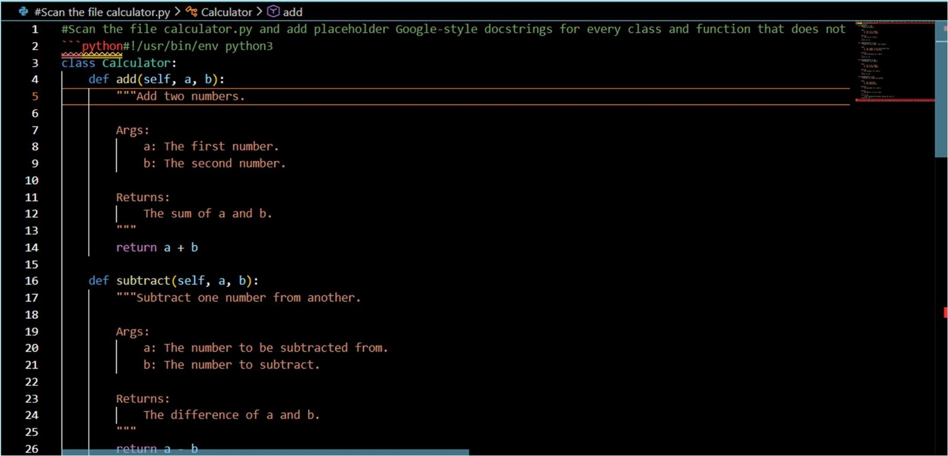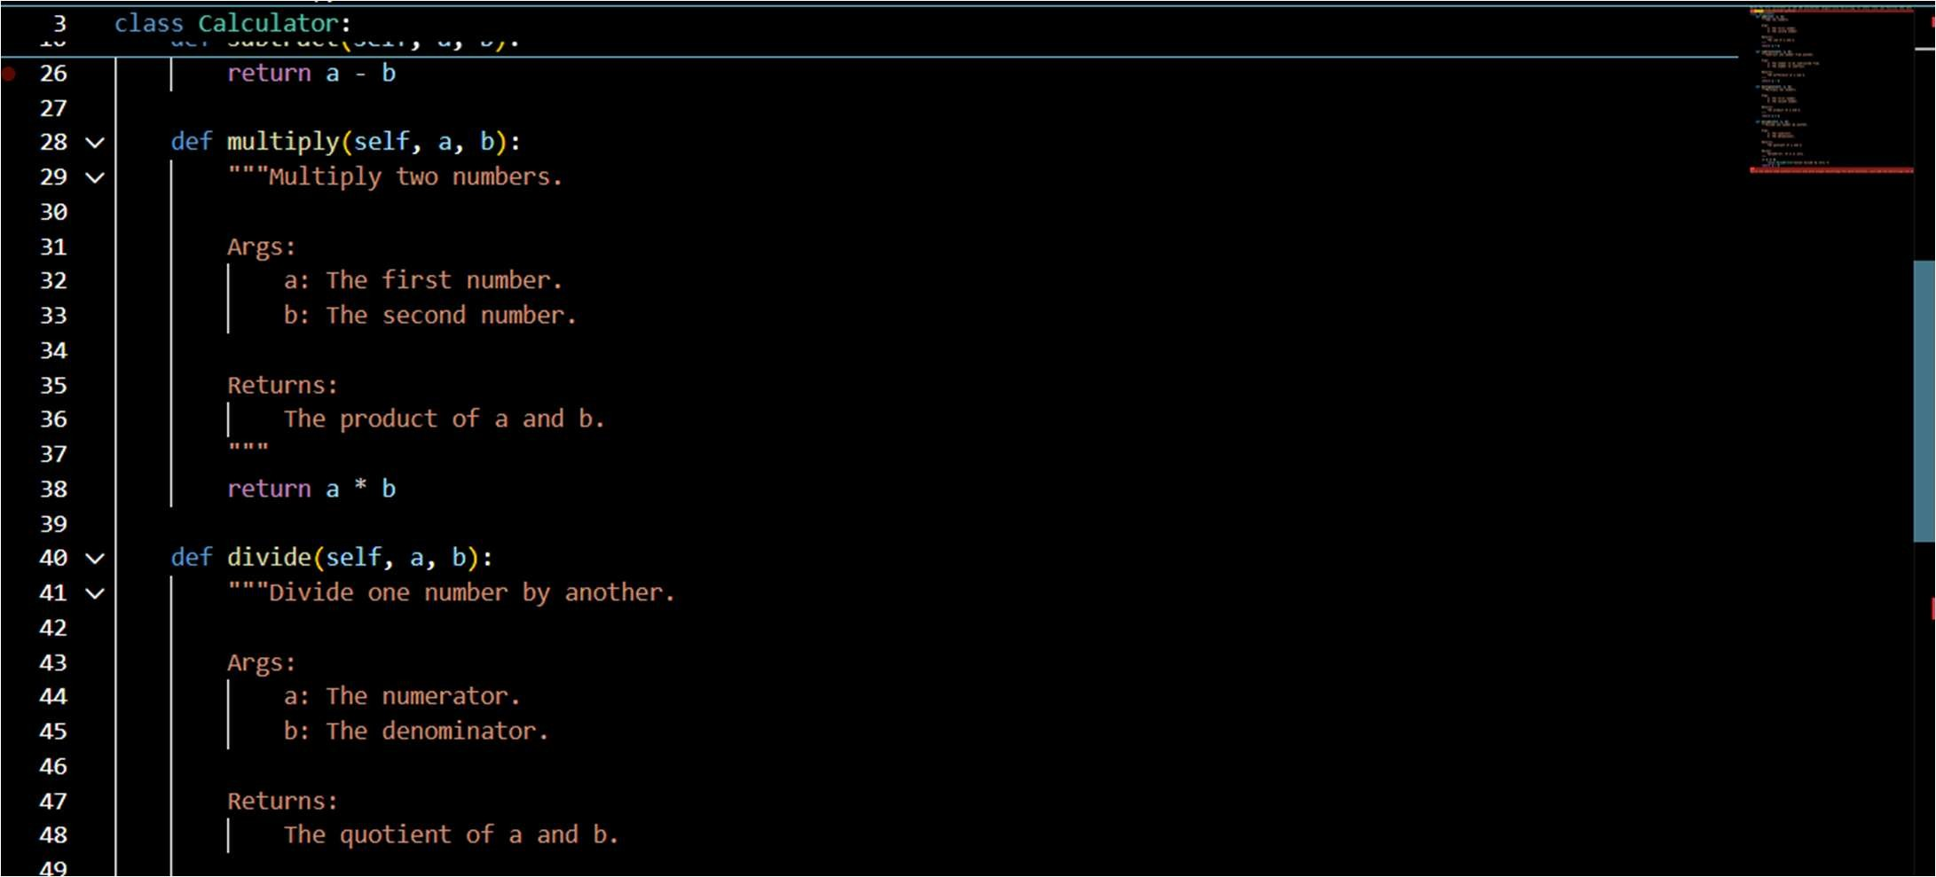
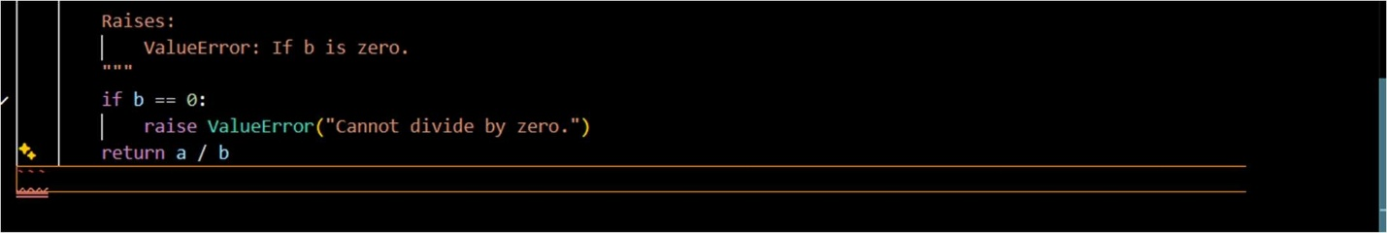
Explana on:
The program implements a Calculator class that handles basic arithmetic operations using clear Google-style docstrings. Each method explains its functionality, inputs, outputs, and possible errors, enhancing readability and maintainability.

